**SQL worksheet -3**

**Refer the following ERD and answer all the questions in this worksheet. You have to write the queries using mysql for the required Operation.**



* **Customers**: stores customer’s data.
* **Products**: stores a list of scale model cars.
* **ProductLines**: stores a list of product line categories.
* **Orders**: stores sales orders placed by customers.
* **OrderDetails**: stores sales order line items for each sales order.
* **Payments**: stores payments made by customers based on their accounts.
* **Employees**: stores all employee information as well as the organization structure such as who reports to whom.
* **Offices**: stores sales office data.

1. Write SQL query to create table Customers**.**

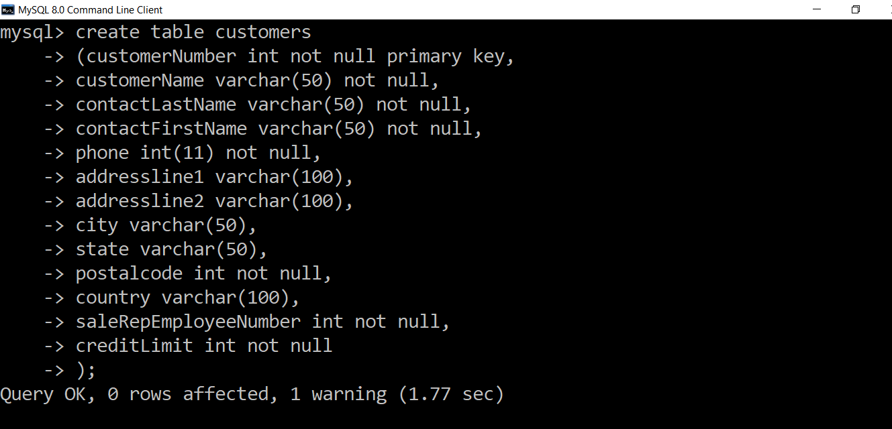

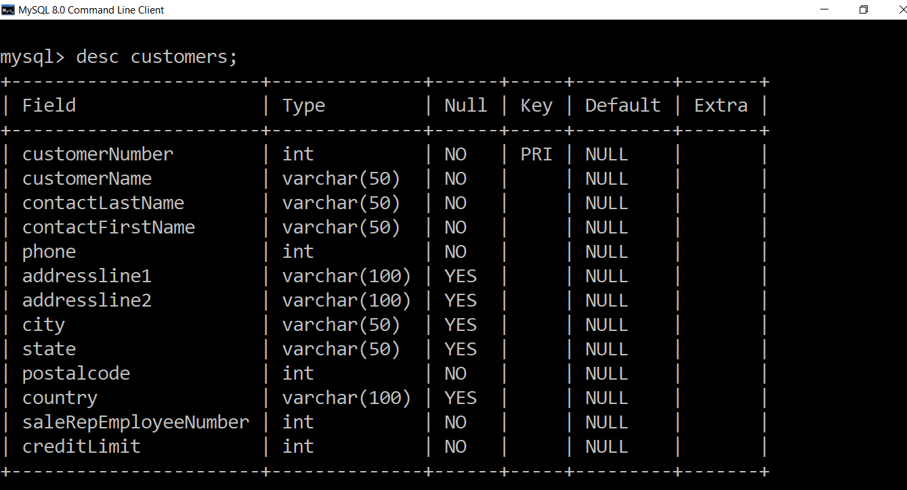

**2. Write SQL query to create table Orders.**

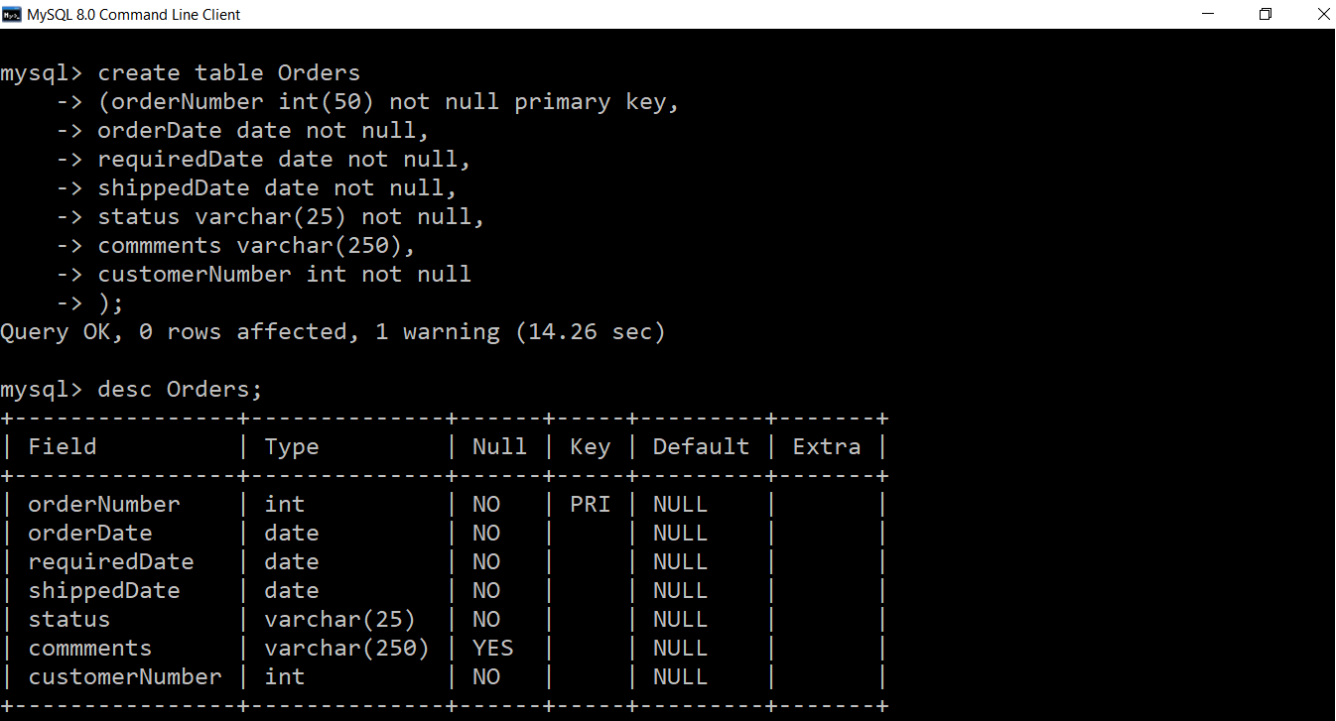

**3. Write SQL query to show all the columns data from the Orders Table.**

select * from Orders;

**4. Write SQL query to show all the comments from the Orders Table**

select comments from Orders;

**5. Write a SQL query to show orderDate and Total number of orders placed on that date, from Orders table**

select orderDate, count(orderNumber) from Orders groupby orderDate ;

**6. Write a SQL query to show employeNumber, lastName, firstName of all the employees from employees table**.

select employeNumber, lastName, firstName from employees;

**7. Write a SQL query to show all orderNumber, customerName of the person who placed the respective order.**

|  |
| --- |
|  |
| Select Orders.orderNumber,Customers.customerName FROM Orders INNER JOIN Customers ON Orders.customerNumber=Customers.customerNumber; |
|  |

**8. Write a SQL query to show name of all the customers in one column and salerepemployee number in another column.**

SELECT customerName,salesRepEmployeeNumber FROM customers;

**9. Write a SQL query to show Date in one column and total payment amount of the payments made on that date from the payments table.**

select paymentDate, sum(amount) from payments groupby paymentDate ;

**10. Write a SQL query to show all the products productName, MSRP, productDescription from the products table.**

select productName, MSRP, productDescription from products;

**11. Write a SQL query to print the productName, productDescription of the most ordered product.**

SELECT productName, productDescription From products JOIN orderdetails WHERE products.productCode=orderdetails.productCode group by orderdetails.productCode having count(orderdetails.productCode) order by count(orderdetails.productCode) DESC

**12. Write a SQL query to print the city name where maximum number of orders were placed**.

select city from orders inner join customers on orders.customerNumber = customers.customerNumber

group by city order by count(orderNumber) desc ;

**13. Write a SQL query to get the name of the state having maximum number of customers.**

select state, count(customerNumber) from customers order by count(customerNumber) group by state;

**14. Write a SQL query to print the employee number in one column and Full name of the employee in the second column for all the employees.**

select employeeNumber , concat(firstName, lastName) as EmpName from employees ;

**15. Write a SQL query to print the orderNumber, customer Name and total amount paid by the customer for that order (quantityOrdered × priceEach).**

SELECT orders.orderNumber, customers.customerName, (orderdetails.quantityOrdered*orderdetails.priceEach) as "Total" FROM customers join orders join orderdetails where customers.customerNumber=orders.customerNumber AND orderdetails.orderNumber=orders.orderNumber